

SteamCleaner

Exploration



Artifact 2

Curtis Murray

CMPT 395 (AS40)

# Artifact 2: Exploration

**Exploring the structure**

Upon loading up the project, we can see 4 folders and several files in the root directory:

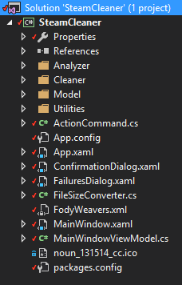

There are several file types in the root directory:

|  |  |
| --- | --- |
| **.cs** | These are C-Sharp files providing the functionality of the program |
| **.xaml** | Pertains to the GUI layout of the program |
| **.ico** | An icon file containing an image |
| **.config** | The configuration of the program and any dependencies it needs |

The GUI of the program is controlled through ‘*MainWindows.xaml*’, ‘*FailuresDialog.xaml*’, ‘*ConfirmationDialog.xaml*’, and ‘*App.xaml*’.

|  |  |
| --- | --- |
| **MainWindows.xaml** | The main window of the program. This is the window that is shown upon loading up the program. |
| **FailuresDialog.xaml** | When the program is unable to delete certain files, this window is displayed which informs the user of the failed deletions and lets the user know which files it had troubles deleting. |
| **ConfirmationDialog.xaml** | Before deleting any files, this window will pop up confirming with the user whether or not they are sure that they want to delete all of the unnecessary files. |
| **App.xaml** | Instead of controlling the GUI directly, this file deals with pulling in all dependencies that the program requires to run. |

|  |  |
| --- | --- |
| **ActionCommand.cs** | This particular C-Sharp file I am still a little unsure of. Following along with the code in MainWindowViewModel.cs it seems as though this file is used to combine certain functions together for easier calling? |
| **FileSizeConverter.cs** | Is used to convert values in certain formats (such as strings) into its corresponding size in Bytes. |
| **MainWindowViewModel.cs** | This is the main control of the program which manages all files that make up the program. |

The remaining files (*App.config, FodyWeavers.xml, noun_131514_cc.ico, packages.config*) are either files containing configuration settings or icons.

Those are the files located in the root directory. Now to move onto each of the folders:

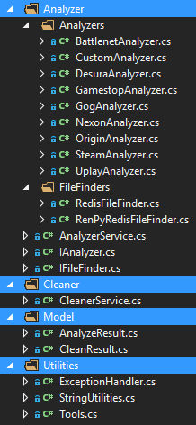

|  |  |
| --- | --- |
| **Analyzer** | This is the bread and butter of the program. Contained in this folder are all of the C-Sharp files that pertain to finding left-over files pertaining to each individual service. I find it quite amusing that this program is called “SteamCleaner” when it actually not only scans for leftover files from Steam but also for other services such as Battlent, Nexon, Origin and more, as you can see in the ‘Analyzer 🡪 Analyzers folder.  AnalyzerService.cs IAnalyzer.cs and IFileFinder.cs are used in conjunction with one another to locate user files on the OS. |
| **Cleaner** | This folder only contains 1 C-Sharp file ‘CleanerService.cs’ which deals with the actual deletion of the found files. |
| **Model** | Despite the name, the two C-Sharp files within this folder focus on dealing with the results collected from each of the scripts in the Analyzer folder. These tie in the analyzers with the cleaner. |
| **Utilities** | All of the helper functions are stored within this folder such as any exception handling procedures or file size conversions. |